**Mental Health Calls for Cardiff and Vale University Health Board (CVUHB) Out of Hours (OOHs) from Jan- May 2020**

The monthly data for CVUHB OOHs service of mental health calls from Jan - May 2020 in comparison to the previous year.

The calls have spiked dramatically since February this year (2020). So far this month (May), mental health is totalling over 3.5% of CVUHB’s work coming into OOHs.

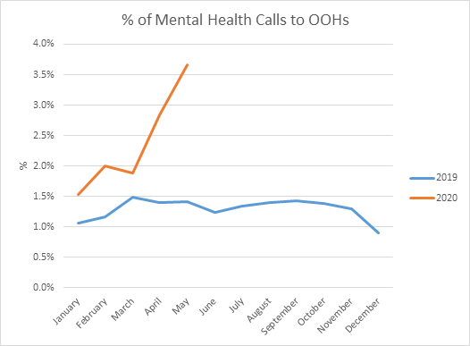

*Source: Cardiff & Vale UHB OOH Service*