Pain rating scale

How does your pain usually make you feel?

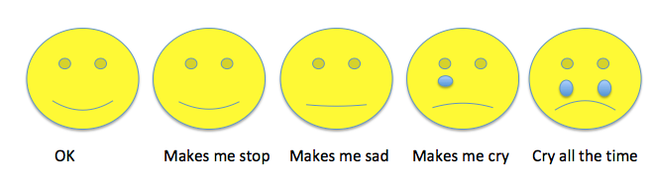
1 2 3 4 5

